Exception Handling and File Processing
Exception Handling
- try
- except
- finally
- raise
Common Exceptions
- ValueError
- TypeError
- IndexError
- FileNotFoundError
File Handling
- Read files
- Write files
- Append files
Working with CSV Files
Hands-on Labs
  - Log file processor
  - Student data file reader
  - Expense tracker
Object-Oriented Programming
OOP Concepts
- Class
- Object
- Attributes
- Methods
Constructors
- __init__()
Encapsulation
Inheritance
Polymorphism
Abstraction
Magic Methods
Hands-on Labs
- Employee Management System
- Banking Application
- Library Management System
Python Libraries and Package Management
Package Management
- pip
- virtual environments
Popular Libraries
- requests
- numpy
- pandas
- matplotlib
Installing and Managing Packages
Hands-on Labs
- API consumption example
- Data visualization example

Exception Handling and File Processing
Both are two very important concepts in Python programming. Exception handling allows a program to respond gracefully to errors, while file processing allows a program to store, retrieve, & manipulate data in files.
Exception Handling
What is an Exception?
An exception is an error or unexpected condition that occurs while a Python program is running. When an exception occurs, Python normally stops the execution of the current program flow & reports the error.
Why is Exception handling Required?
Without exception handling, an unexpected error can terminate the program.
Exception handling allows developers to:
- Prevent unexpected program terminate
- Display meaningful error messages
- Handle different types of errors differently
- Continue program execution where appropriate
- Perform cleanup operations
- Makes applications more reliable
- Separate normal program logic from error-handling logic
Exception handling mechanism
Python provides structured exception handling using following keywords:
- try
- except
- else
- finally
- raise
The general flow is:
try -> exception occurs -> except handles it -> else/finally executes as appropriate
Common Exceptions
- ZeroDivisionError – Occors when a number is divided by zero.
- ValueError – Occurs when a value has the correct general type but an inappropriate value.
- TypeError – Occurs when an operation is performed using an inappropriate data type.
- IndexError – Occurs when attempting to access an index outside the valid range of a sequence.
- KeyError – Occurs when attempting to access a dictionary using a key that doesn’t exist.
- FileNotFoundError – Occurs when attempting to open a file that doesn’t exist at the specified location.
File Processing in Python
What is File Processing?
File processing refers to reading of data from files, writing data to files, modifying file contents, & managing files using a Python program.
Unlike variables, which normally contain data only while the program is running, files allow information to be stored & retrieved later.
Types of Files
- Text Files
- Binary Finally
- Read files
- Write files
- Append files
Working with CSV Files
Hands-on Labs
Lab 1: Log File Processor
1. Lab Title
Log File Processor
2. Objective
Develop a Python application that reads an application log file, processes individual log entries, identifies different log levels, detects invalid records, generates statistics, and produces a summary report.
3. Business Scenario
An application generates a log file containing information about system activities, warnings, errors, and debugging information.
The operations team wants a Python utility that can automatically analyze the log file and provide:
- Number of log entries
- Log-level statistics
- Error details
- Warning details
- Invalid records
- Processing summary
4. Input File
Create a file named:
application.log
Each valid record should follow this format:
Date Time LogLevel Message
Example:
2026-09-25 09:15:21 INFO Application started
2026-09-25 09:17:12 WARNING Database response time exceeded 2 seconds
2026-09-25 09:18:45 ERROR Database connection failed
2026-09-25 09:20:33 ERROR File not found: configuration.json
Use the following log levels:
- INFO
- WARNING
- ERROR
- DEBUG
Create at least 30 log entries.
Also include some invalid records for testing.
Examples of invalid records:
- Missing date
- Missing time
- Missing log level
- Unknown log level
- Incomplete message
- Completely malformed record

5. Functional Requirements
Requirement 1 – Read Log File
The application must:
- Open the log file.
- Read the file line by line.
- Process each log record individually.
- Close the file appropriately after processing.
Requirement 2 – Validate Log Records
Each record must be checked for:
- Valid date
- Valid time
- Supported log level
- Message availability
- Correct record structure
Invalid records must not stop the entire processing operation.
Requirement 3 – Process Log Levels
Count the number of:
- INFO messages
- WARNING messages
- ERROR messages
- DEBUG messages
Requirement 4 – Extract Error Messages
Create a collection containing all ERROR records.
The application should display:
- Date
- Time
- Error message
Requirement 5 – Extract Warning Messages
Create a collection containing all WARNING records.
Requirement 6 – Identify Invalid Records
Maintain a separate collection of invalid log entries.
For every invalid record, record:
- Original log entry
- Reason for failure
Requirement 7 – Generate Statistics
Generate:
- Total records
- Valid records
- Invalid records
- INFO count
- WARNING count
- ERROR count
- DEBUG count
Requirement 8 – Generate Error Report
Create:
error_report.txt
The file should contain all error messages found in the log.
Requirement 9 – Generate Summary Report
Create:
log_report.txt
The report should contain:
- File name
- Total records
- Valid records
- Invalid records
- Log-level statistics
- Errors
- Warnings
- Invalid records

6. Exception Handling Requirements
Handle at least:
- File not found
- Permission error
- Invalid log format
- Invalid date/time
- Invalid log level
- Unexpected processing errors
The application should continue processing valid records even when individual records are invalid.

7. Custom Exception Requirement
Create a custom exception named:
InvalidLogEntryError
Use it when a log entry violates the expected format or business rules.
The exception should be handled without terminating the complete application.

8. Expected Output
The application should produce a summary similar to:
LOG FILE ANALYSIS REPORT
Metric | Result
Total Records | Calculated
Valid Records | Calculated
Invalid Records | Calculated
INFO | Calculated
WARNING | Calculated
ERROR | Calculated
DEBUG | Calculated
It should also display the location of the generated reports.

9. Advanced Challenges
Add the following features:
- Search logs by keyword.
- Filter logs by log level.
- Filter logs by date.
- Generate separate files for INFO, WARNING, ERROR, and DEBUG.
- Identify frequently occurring error messages.
- Generate a JSON summary of log statistics.

Lab 2: Student Data File Reader
1. Lab Title
Student Data File Reader
2. Objective
Develop a Python application that reads student information from a CSV file, validates student records, calculates academic performance, analyzes results, and generates a student performance report.
3. Business Scenario
A training institute maintains student information in a CSV file.
The institute wants to automate the processing of student records and generate:
- Student performance details
- Grades
- Pass/fail results
- Course statistics
- Class statistics
- Top performers
- Invalid-record reports

4. Input File
Create:
students.csv
The file should contain:
Field | Description
Student ID | Unique student identifier
Student Name | Student's full name
Course | Enrolled course
Python | Python marks
SQL | SQL marks
Cloud | Cloud Computing marks
Create at least 15 valid records.
Also include invalid records such as:
- Missing Student ID
- Duplicate Student ID
- Missing student name
- Invalid marks
- Marks greater than 100
- Negative marks
- Missing course
- Non-numeric marks

5. Functional Requirements
Requirement 1 – Read Student File
The application must:
- Open the CSV file.
- Read student records.
- Process each record.
- Close the file properly.
Requirement 2 – Validate Student Records
Validate:
- Student ID
- Student name
- Course
- Subject marks
- Duplicate IDs
- Mandatory fields
Requirement 3 – Calculate Total Marks
Calculate the total marks obtained in all subjects.
Requirement 4 – Calculate Percentage
Calculate the student's overall percentage.
Requirement 5 – Determine Grade
Use the following grading criteria:
Percentage | Grade
90–100 | A+
80–89 | A
70–79 | B
60–69 | C
50–59 | D
Below 50 | F
Requirement 6 – Determine Result
Determine whether each student has:
- Passed
- Failed
Requirement 7 – Search Student
Provide options to search using:
- Student ID
- Student name
If the student does not exist, display an appropriate message.
Requirement 8 – Course-Wise Statistics
Calculate for each course:
- Number of students
- Average percentage
- Highest percentage
- Lowest percentage
- Number of passed students
- Number of failed students
Requirement 9 – Identify Top Performer
Identify the student with the highest percentage.
Display:
- Student ID
- Name
- Course
- Percentage
- Grade
Requirement 10 – Identify Failed Students
Generate a list of all failed students.
Requirement 11 – Generate Report
Create:
student_report.txt
The report should contain:
- Student performance
- Overall statistics
- Course-wise statistics
- Top performer
- Failed students
- Invalid records

6. Exception Handling Requirements
Handle:
- File not found
- Permission errors
- Missing fields
- Invalid Student ID
- Invalid marks
- Duplicate Student ID
- Invalid numeric values
- Unexpected errors
Invalid records must be reported without terminating the application.

7. Custom Exception Requirement
Create:
InvalidStudentRecordError
Use it for application-specific validation errors such as:
- Invalid marks
- Missing mandatory data
- Duplicate Student ID
- Invalid Student ID

8. Expected Output
Generate a summary similar to:
STUDENT PERFORMANCE SUMMARY
Metric | Result
Total Records | Calculated
Valid Records | Calculated
Invalid Records | Calculated
Passed Students | Calculated
Failed Students | Calculated
Class Average | Calculated
Highest Percentage | Calculated
Lowest Percentage | Calculated

9. Advanced Challenges
Add features to:
- Sort students by percentage.
- Sort students by name.
- Filter students by course.
- Filter students by grade.
- Search students within a percentage range.
- Export failed students to another CSV file.
- Export processed student data to JSON.
- Generate a course-wise report.

Lab 3: Expense Tracker
1. Lab Title
Personal Expense Tracker
2. Objective
Develop a Python application that maintains personal expense records in a CSV file and provides functionality for recording, viewing, searching, analyzing, and reporting expenses.
3. Business Scenario
A user wants to maintain a digital record of daily expenses.
The application should help the user understand:
- Total spending
- Category-wise spending
- Monthly spending
- Payment-method usage
- Highest and lowest expenses
- Average spending
- Budget utilization

4. Input File
Create:
expenses.csv
The file should contain:
Field | Description
Expense ID | Unique expense identifier
Date | Expense date
Category | Expense category
Description | Expense description
Amount | Amount spent
Payment Method | Payment method used
Use categories such as:
- Food
- Transport
- Shopping
- Bills
- Entertainment
- Healthcare
- Education
- Other
Use payment methods such as:
- Cash
- Card
- UPI
- Bank Transfer
Create at least 20 expense records.

5. Functional Requirements
Requirement 1 – Read Expense File
The application must:
- Read the CSV file.
- Process expense records.
- Validate each record.
- Handle invalid records appropriately.
Requirement 2 – Add Expense
Allow the user to enter:
- Expense ID
- Date
- Category
- Description
- Amount
- Payment method
The new expense should be stored in the CSV file.
Requirement 3 – Validate Expense
Validate:
- Unique Expense ID
- Valid date
- Valid category
- Valid payment method
- Positive amount
- Required fields
Reject:
- Duplicate IDs
- Negative amounts
- Zero amounts
- Invalid dates
- Invalid categories
- Invalid payment methods
Requirement 4 – View Expenses
Display all expense records in a structured format.
Requirement 5 – Search Expenses
Allow searching by:
- Expense ID
- Date
- Category
- Description
- Payment method
Requirement 6 – Calculate Total Expenses
Calculate:
- Total number of expenses
- Total expenditure
- Average expense
- Highest expense
- Lowest expense
Requirement 7 – Category-Wise Analysis
Calculate expenditure for each category.
Example:
Category | Total
Food | Calculated
Transport | Calculated
Shopping | Calculated
Bills | Calculated
Entertainment | Calculated
Identify the category with the highest expenditure.
Requirement 8 – Payment-Wise Analysis
Calculate expenditure for:
- Cash
- Card
- UPI
- Bank Transfer
Requirement 9 – Monthly Analysis
Allow the user to select a month and calculate:
- Number of expenses
- Total expenditure
- Average expense
- Highest expense
- Lowest expense
Requirement 10 – Date-Range Analysis
Allow the user to specify a start date and end date.
Display all expenses within that period and calculate the total.
Requirement 11 – Identify Highest Expense
Display:
- Expense ID
- Date
- Category
- Description
- Amount
- Payment method
Requirement 12 – Generate Expense Report
Create:
expense_report.txt
The report should contain:
- Overall expense summary
- Category-wise summary
- Payment-wise summary
- Monthly summary
- Highest expense
- Lowest expense
- Average expense

6. Exception Handling Requirements
Handle:
- File not found
- Permission errors
- Invalid date
- Invalid amount
- Invalid Expense ID
- Duplicate Expense ID
- Invalid category
- Invalid payment method
- Missing fields
- Unexpected errors
The application should continue operating after recoverable errors.

7. Custom Exception Requirement
Create:
InvalidExpenseError
Use it for business-rule violations such as:
- Negative expense
- Zero expense
- Invalid category
- Invalid payment method
- Duplicate Expense ID

8. Menu Requirements
The application should provide a menu containing:
- Add Expense
- View Expenses
- Search Expenses
- Total Expenses
- Category-Wise Summary
- Payment-Wise Summary
- Monthly Summary
- Date-Range Summary
- Highest Expense
- Generate Report
- Exit
The application should continue running until the user selects Exit.

9. Expected Output
Generate an expense summary containing:
Metric | Result
Number of Expenses | Calculated
Total Expenditure | Calculated
Average Expense | Calculated
Highest Expense | Calculated
Lowest Expense | Calculated
Also generate:
Category Summary
Category | Expenditure
Food | Calculated
Transport | Calculated
Shopping | Calculated
Bills | Calculated
Entertainment | Calculated
Payment Summary
Payment Method | Expenditure
Cash | Calculated
UPI | Calculated
Card | Calculated
Bank Transfer | Calculated

10. Advanced Challenges
Challenge 1 – Monthly Budget
Allow the user to define a monthly budget and calculate:
- Budget
- Total expenditure
- Remaining budget
- Budget utilization percentage
Generate a warning if the budget is exceeded.
Challenge 2 – Spending Alerts
Allow configurable spending limits for individual categories.
Generate an alert when a category exceeds its configured limit.
Challenge 3 – JSON Backup
Export all expense records into a JSON file.
Challenge 4 – Expense Statistics
Calculate:
- Most frequently used category
- Most frequently used payment method
- Average daily expenditure
- Number of expenses per category
- Number of expenses per payment method
Challenge 5 – Separate Reports
Generate separate reports for:
- Food
- Shopping
- Transport
- Bills
- Entertainment
- Invalid records

Combined Learning Outcomes
After completing all three labs, students should be able to:
- Work with text and CSV files.
- Read files sequentially.
- Write and append files.
- Parse structured data.
- Validate input data.
- Process malformed records.
- Use lists and dictionaries for data processing.
- Perform calculations and aggregation.
- Search and filter file contents.
- Generate text reports.
- Handle built-in exceptions.
- Create custom exceptions.
- Work with JSON files.
- Build menu-driven file-processing applications.
- Apply file handling to realistic business scenarios.
Recommended Lab Progression
Lab | Primary Skills
Log File Processor | Reading, parsing, filtering, exception handling
Student Data File Reader | CSV processing, validation, calculations, reporting
Expense Tracker | Reading/writing, record management, aggregation, searching, reporting

Object-Oriented Programming
Object-Oriented programming (OOP) is a programming paradigm that organizes software around objects rather than only functions & procedures.
An object represents an entity that contains:
- Unique Identity
- Data (Characteristics)
- Responsibilities
- Behavior
Why Object-Oriented Programming?
As applications become larger, managing everything through independent variables & functions can become difficult.
OOP helps organize an application into logical entities.
Without OOP
A large application may contain:
- Many independent variables
- Numerous functions
- Shared data
- Complex relationships between functions
- Difficult to maintain dependencies
With OOP
The application can be organized into:
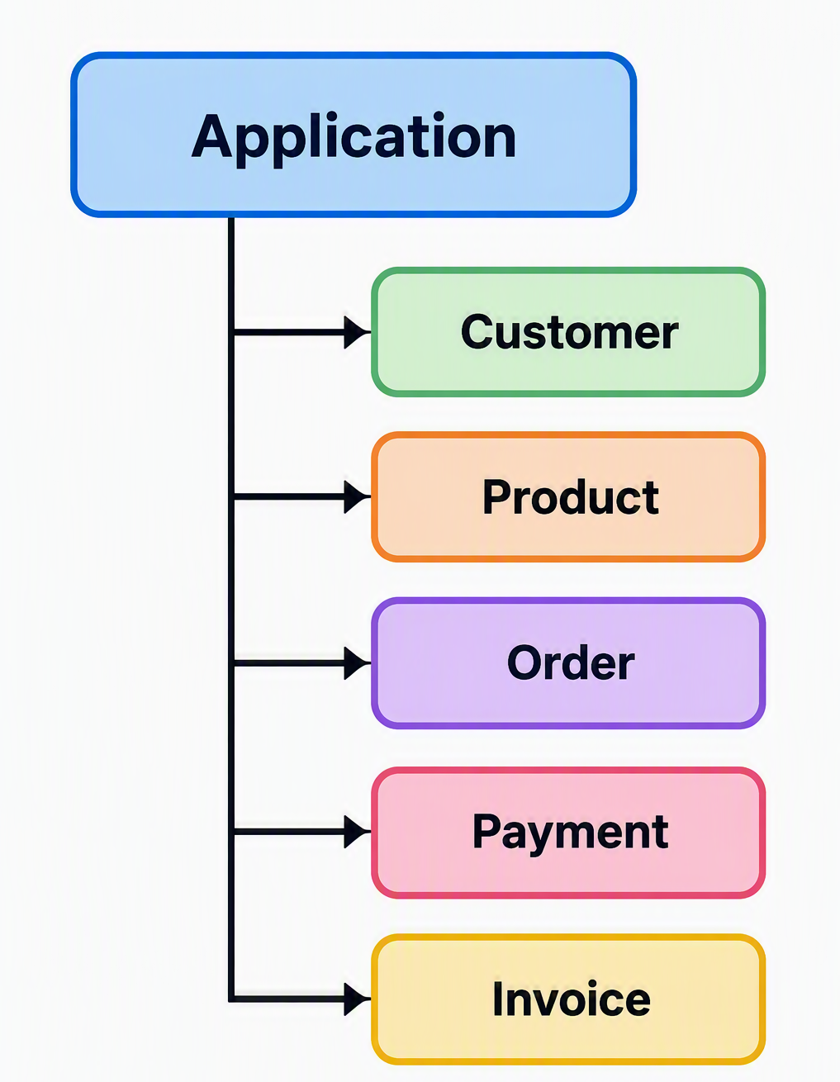

Class
A class is a blueprint or template used to create objects which defines the characteristics, behaviours, responsibilities that objects of that type will possess.
Object
An object is an instance of a class.
Attributes
Attributes represent the data or characteristics associated with an object.
Methods
A method is a function associated with a class or object.
Constructor
A constructor is special method that is automatically invoked when an object is created.
In Python, the commonly used constructor as __init__().
It’s primary purpose is to initialize object’s attributes.
Instance
An instance is another term commonly used for an object created from a class.
Major Pillars/Principles of OOP
- Abstraction
Abstraction is the process of setting the minimum expectation from an object.
- Encapsulation
Encapsulation is about combining data & the operations that work on that data within a single unit, usually a class.
- Inheritance
Inheritance allows a class to acquire characteristics & behaviours from another class.
- Polymorphism
Polymorphism allows the same interface or operation to behave differently depending on the object involved.
Implemented using Method Overriding

Special (magic/dunder) methods in Python
  - __init__()
  - __str__()
  - __repr__()
  - __len__()
  - __eq__()

